**Lab 27**

**Access S3 via EC2 with Full access – By using IAM**

Click “S3” service

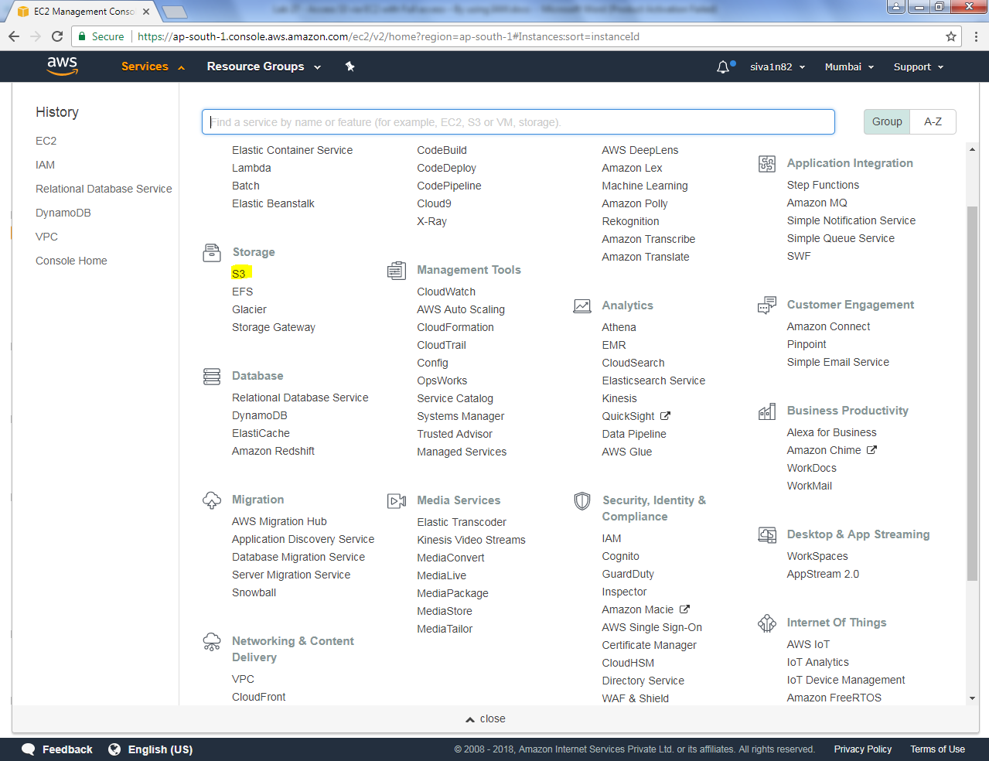

Click “Create bucket”.

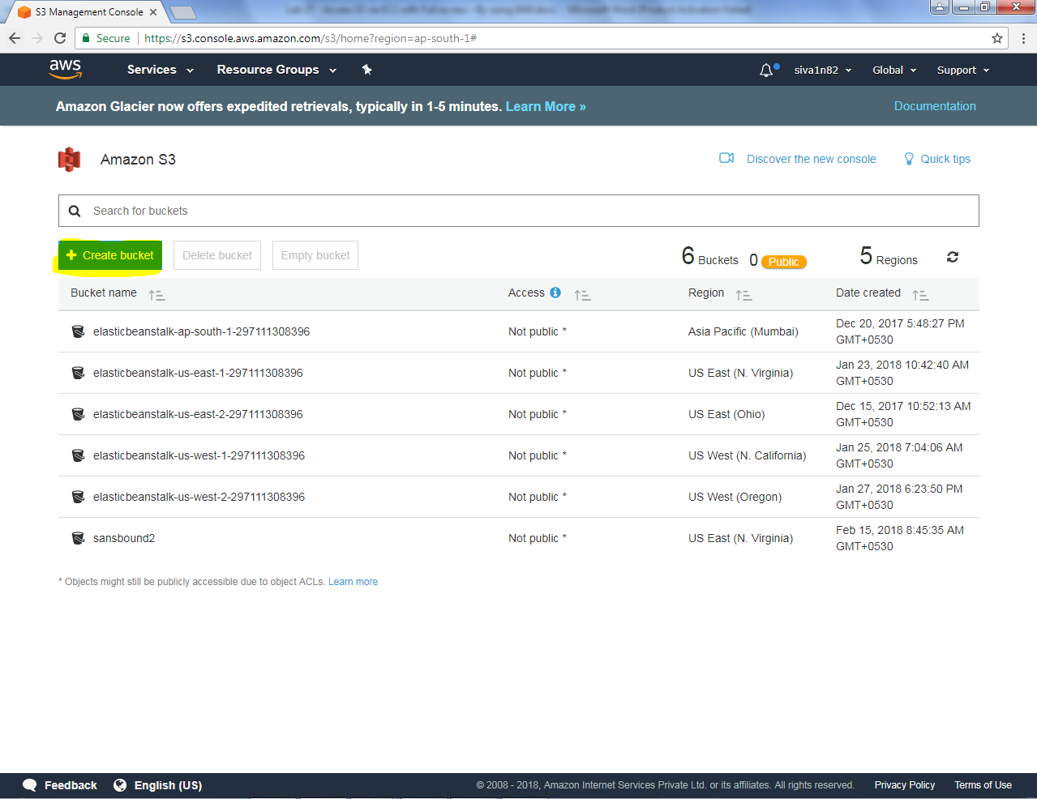

Type sansboundd3.com

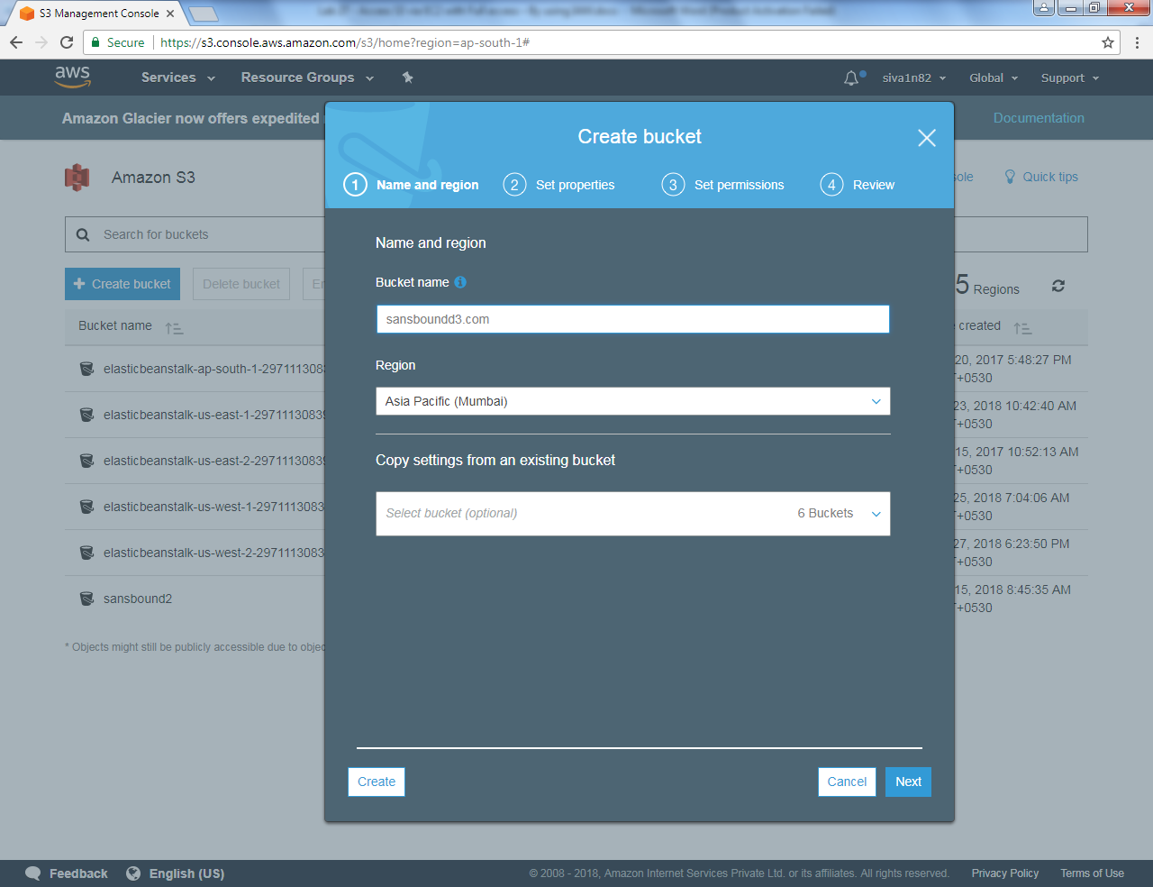

Bucket has been successfully created.

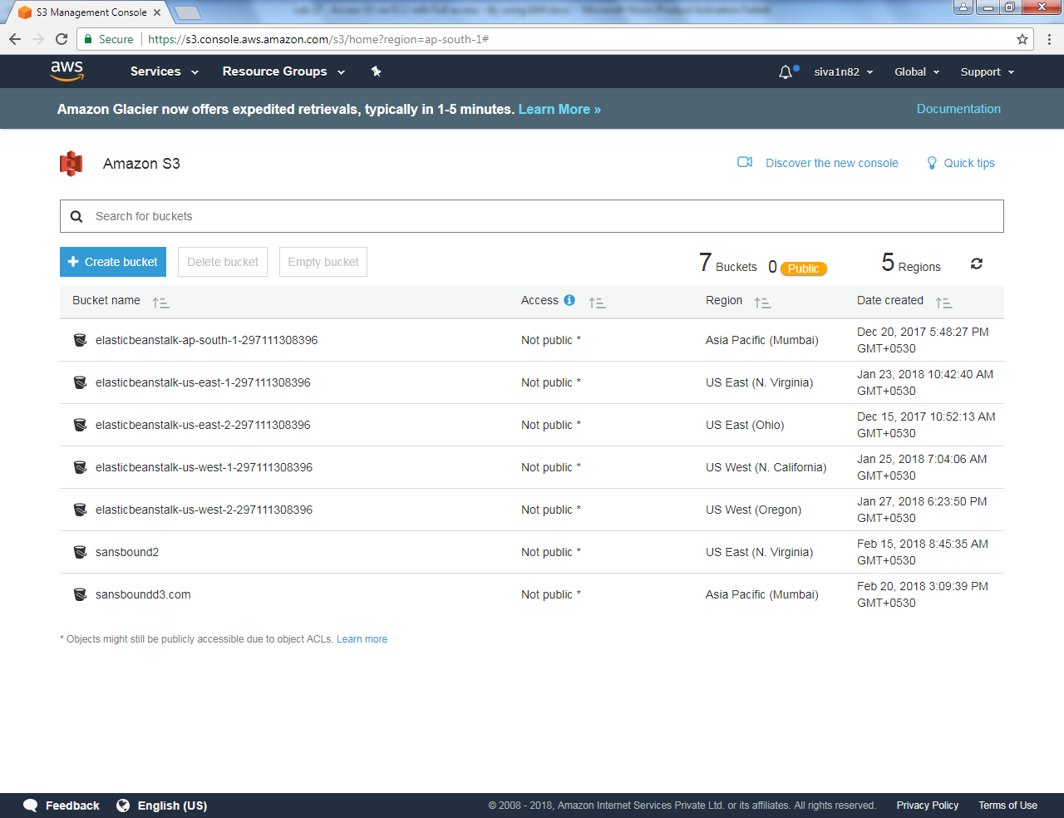

Click “IAM” service

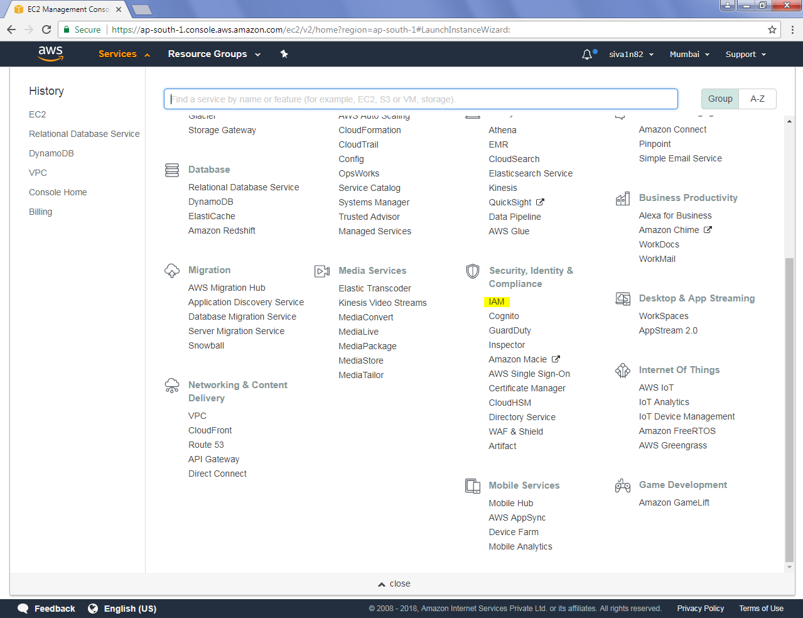

Click “Users”.

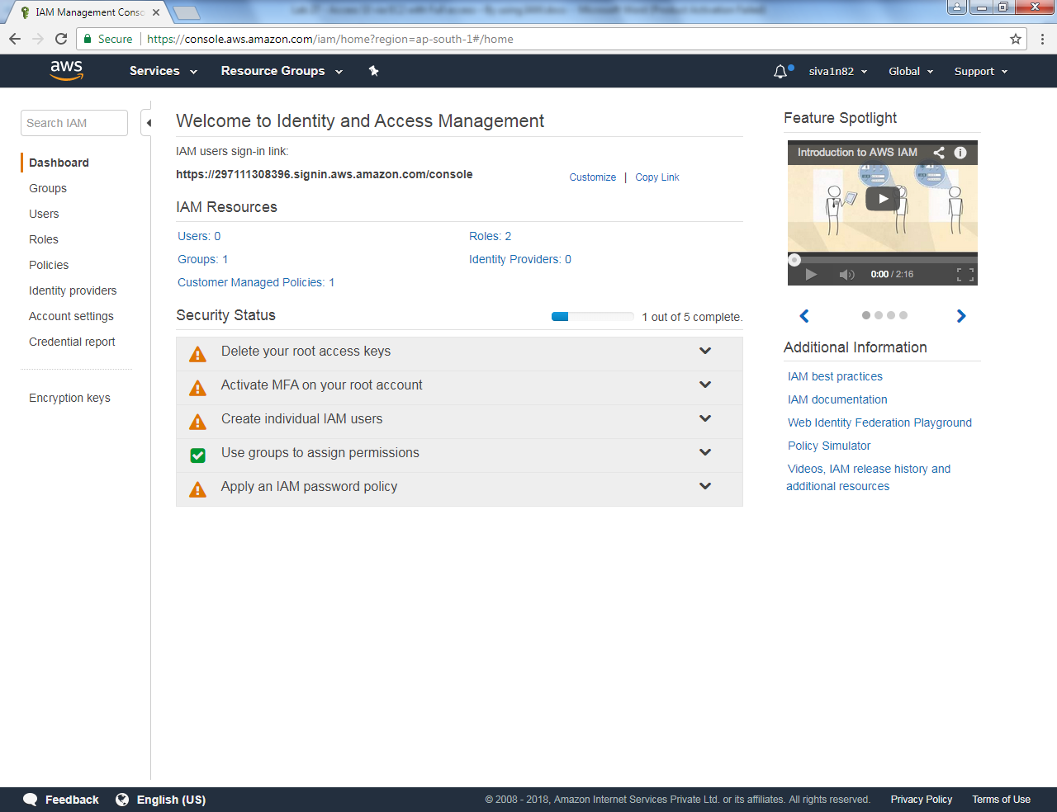

Click “Add user”.

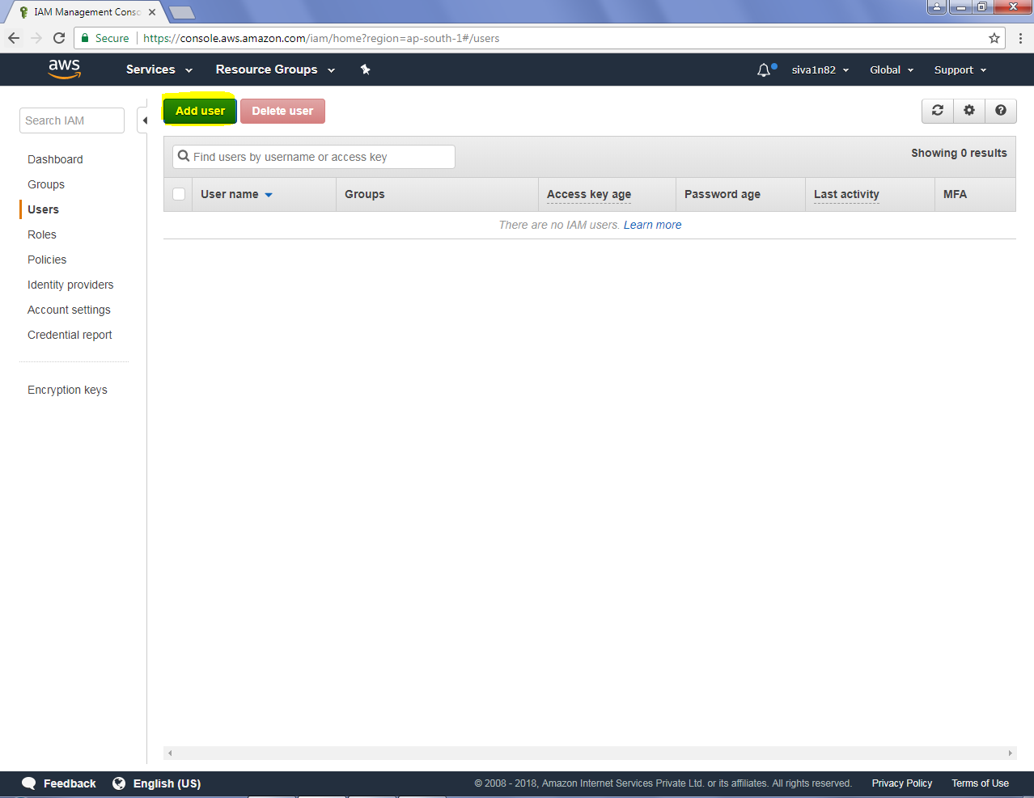

Type user name and select the access type as programmatic access.

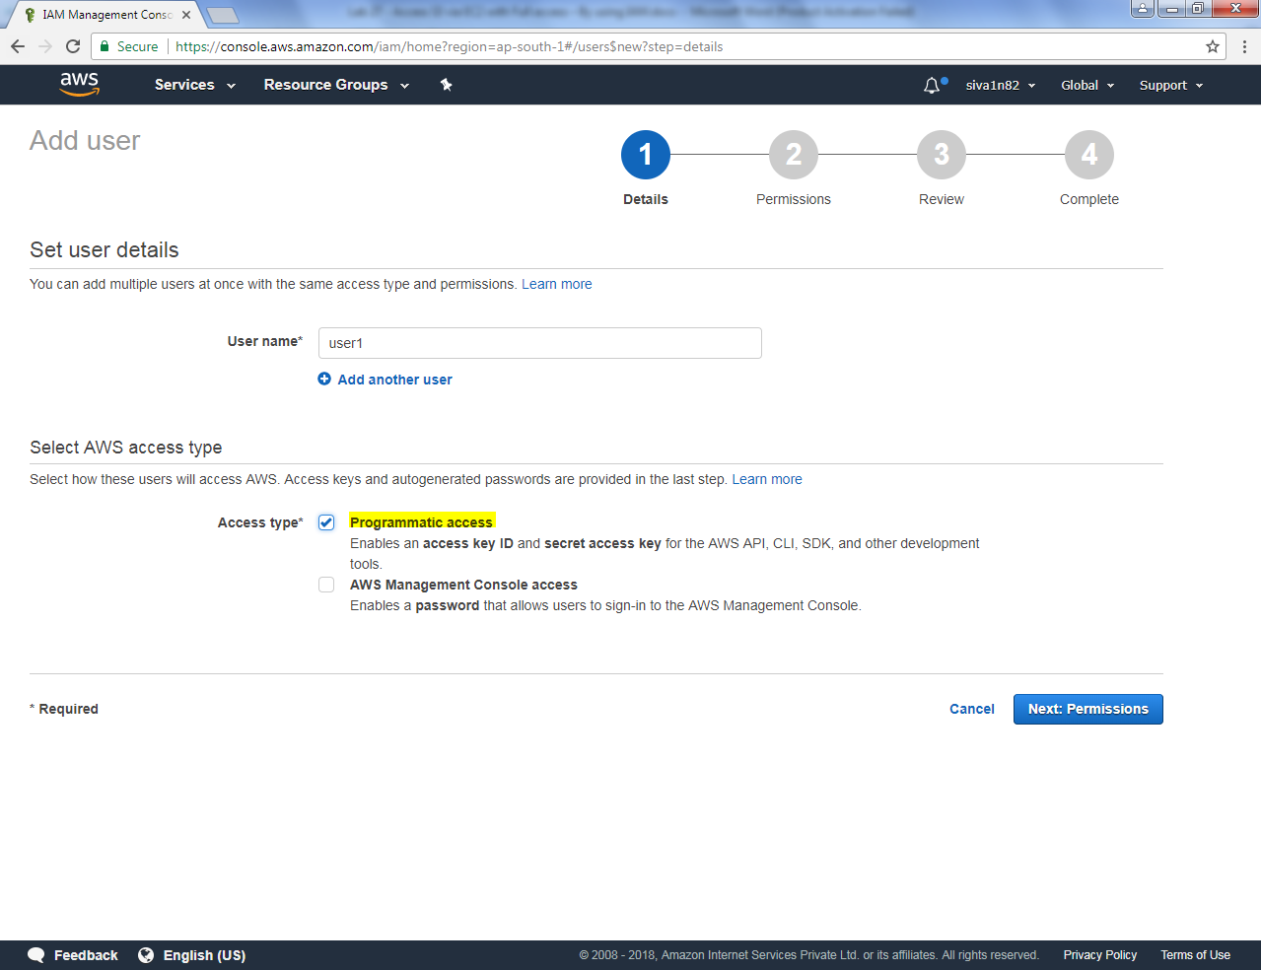

Click “Next”.

Select attach existing policies directly and provide **AmazonS3 Full access.**

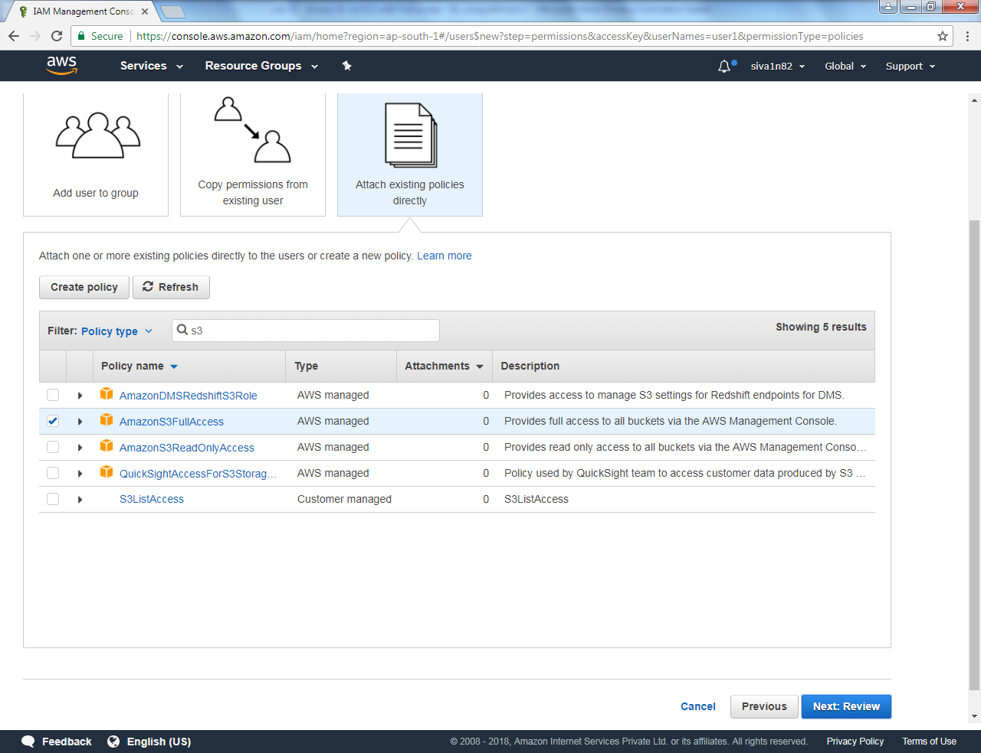

Click “Next”.

Click “Create user”.

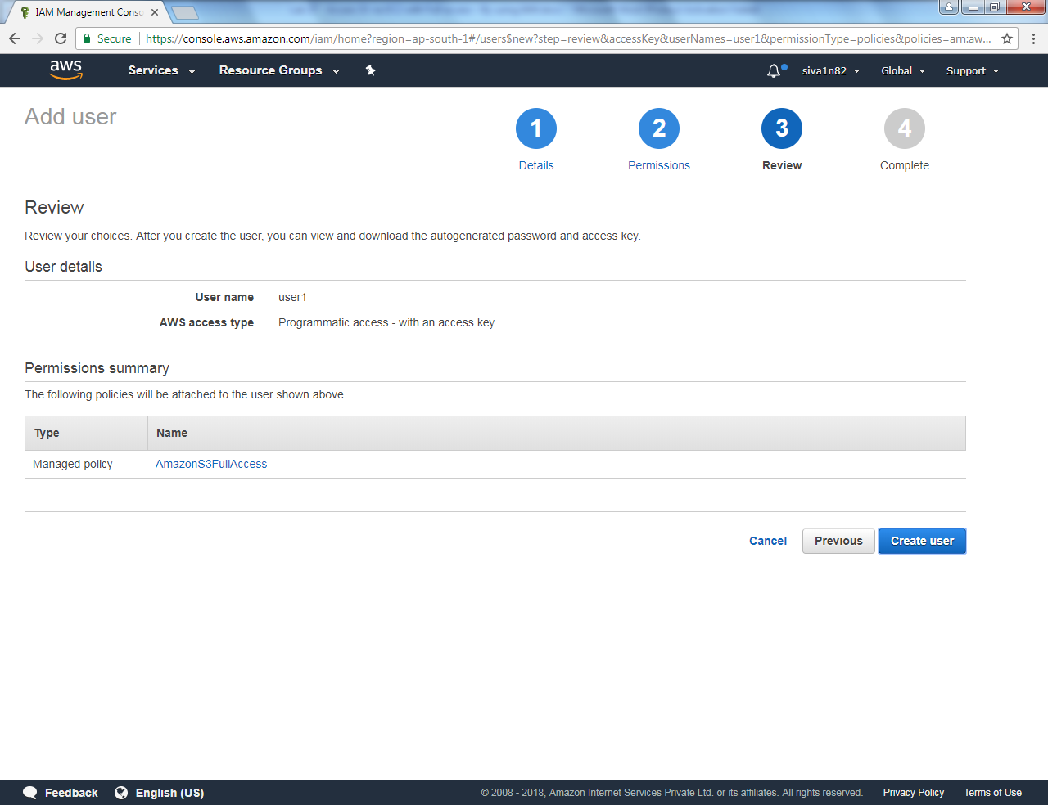

You can able to view the access key.

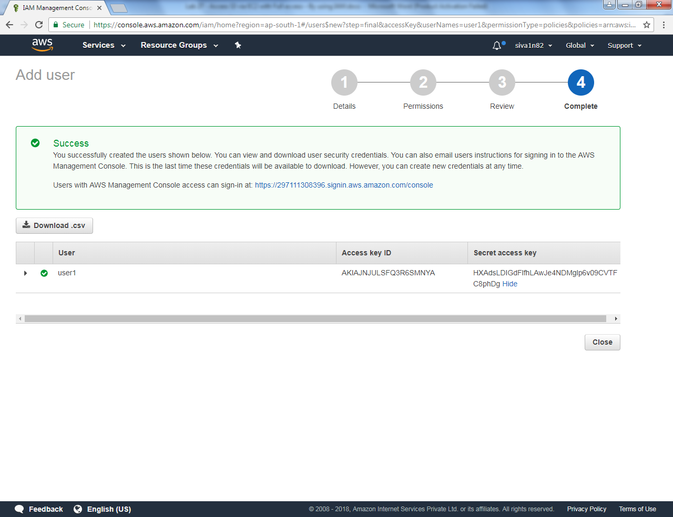

You can able to view the user.

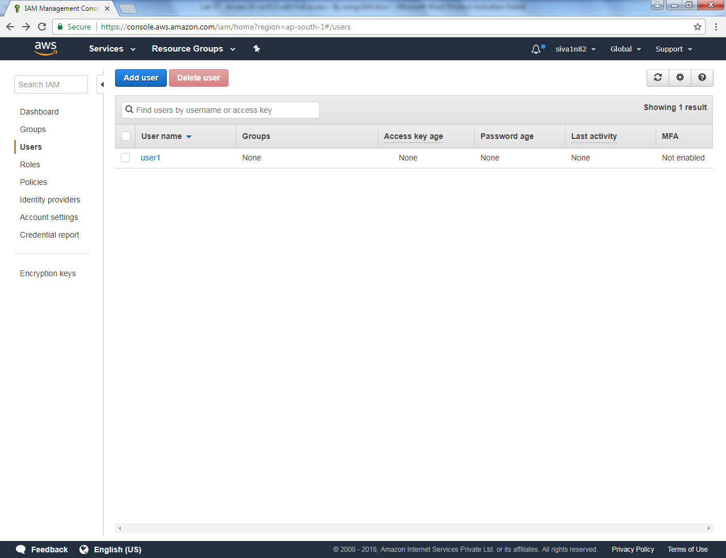

Click Roles and click create role.

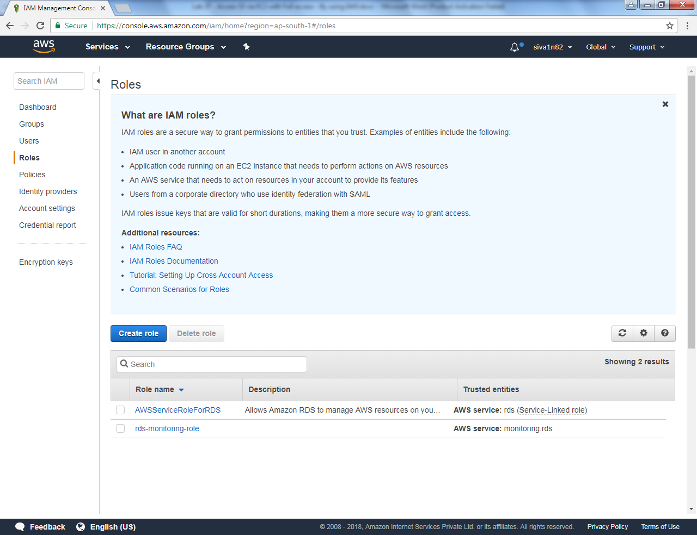

Click “EC2” Service

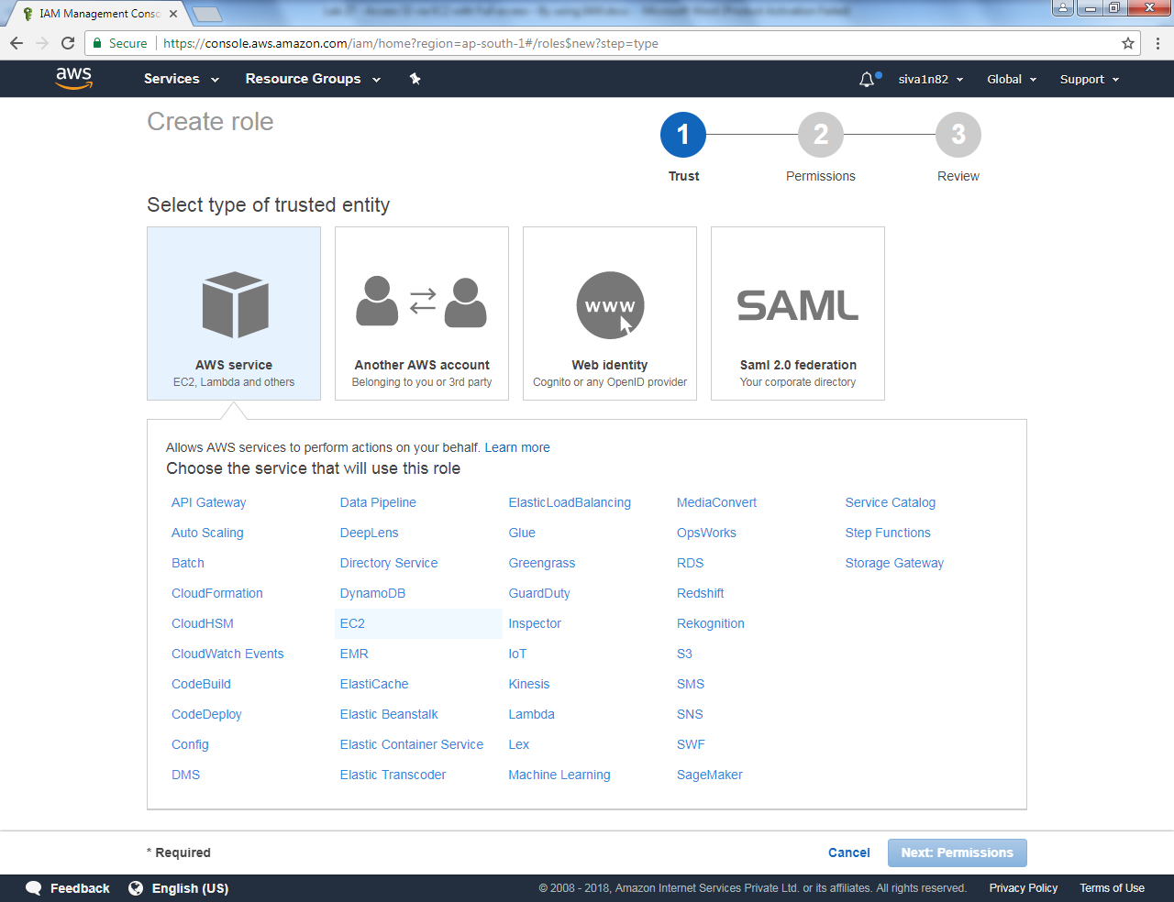

Click “EC2” service.

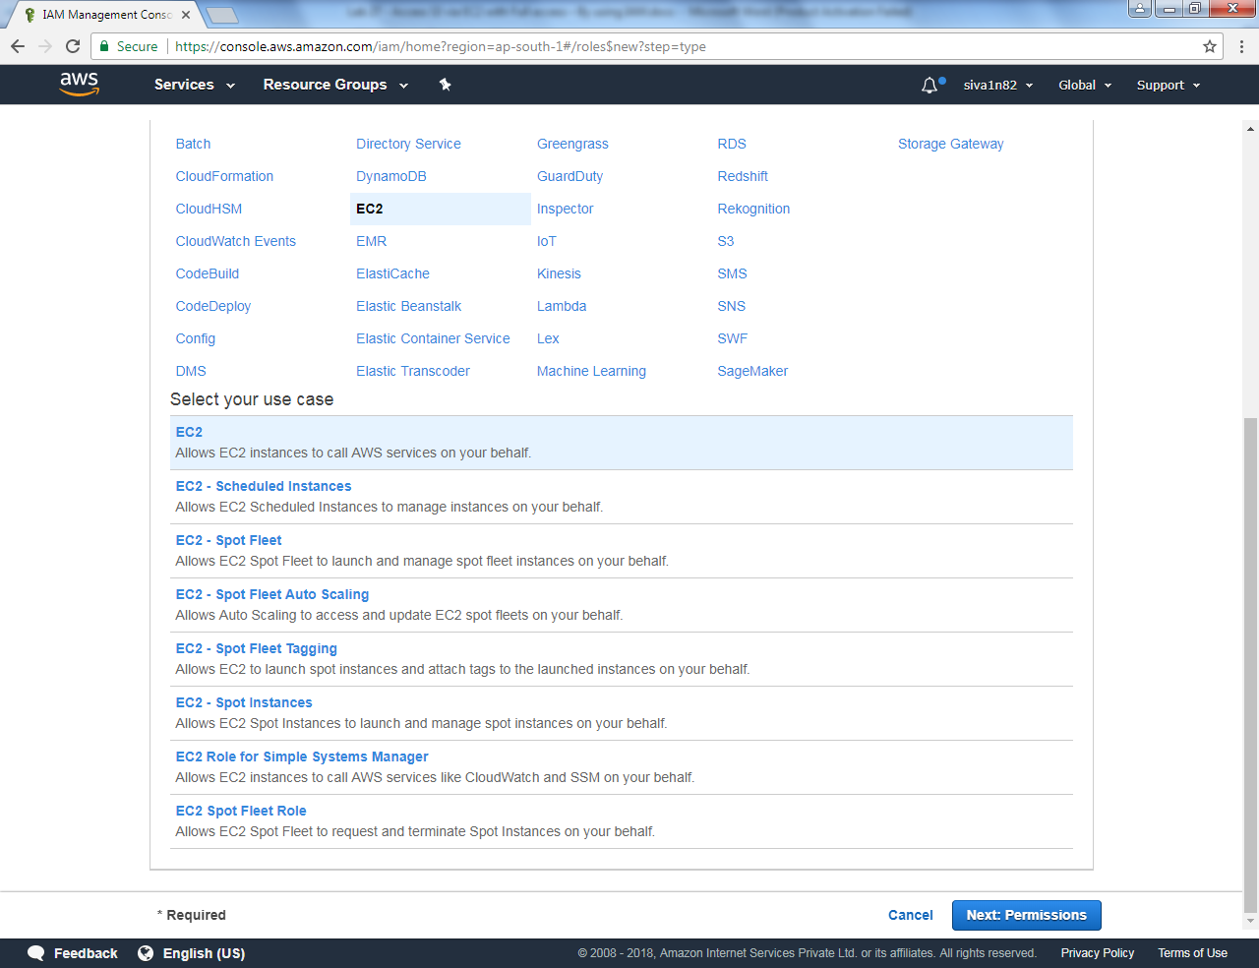

Select **“AmazonS3 Full access”**

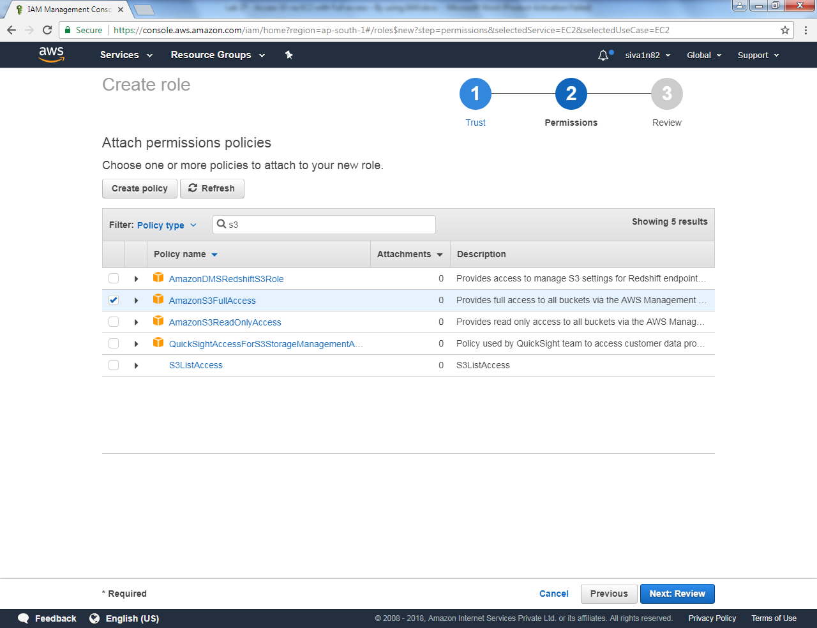

Type role name as “S3AccesswithEC2” and click “Create role”.

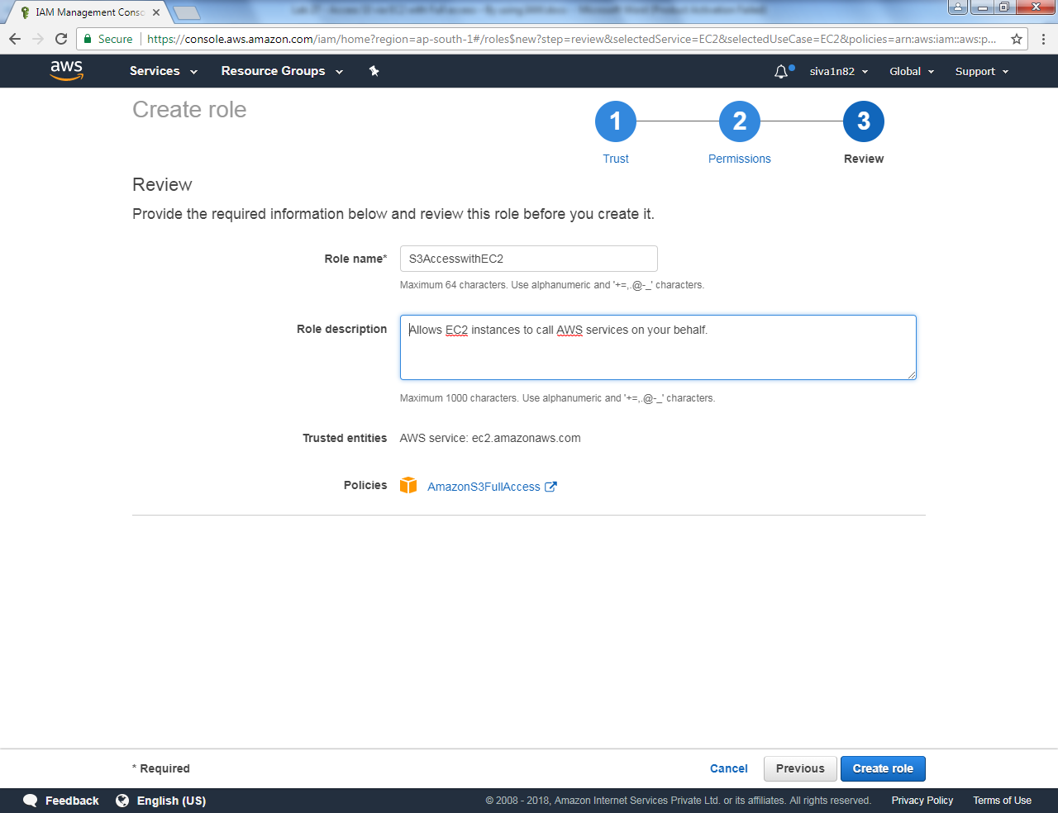

You can able to view the roles as below.

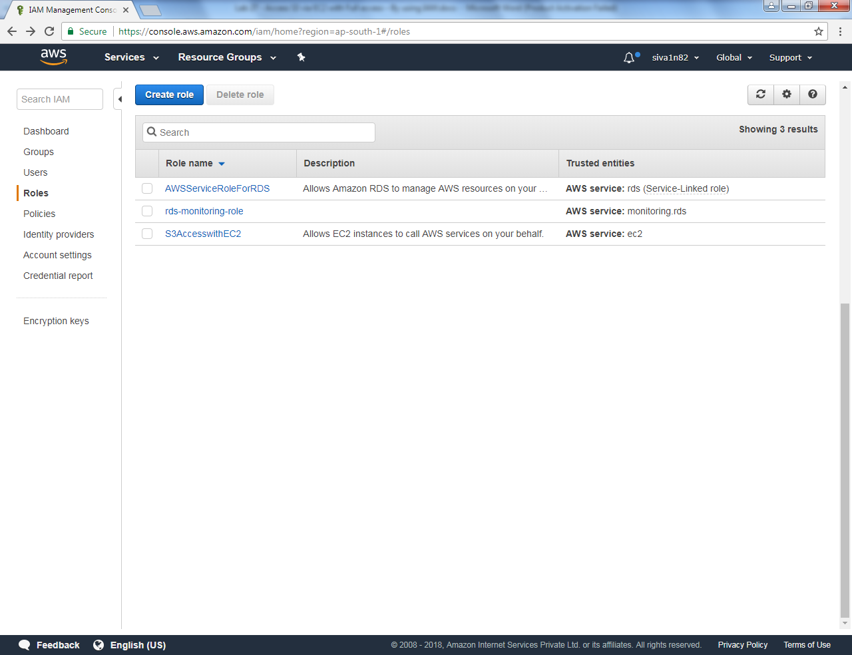

Click “Launch instance”.

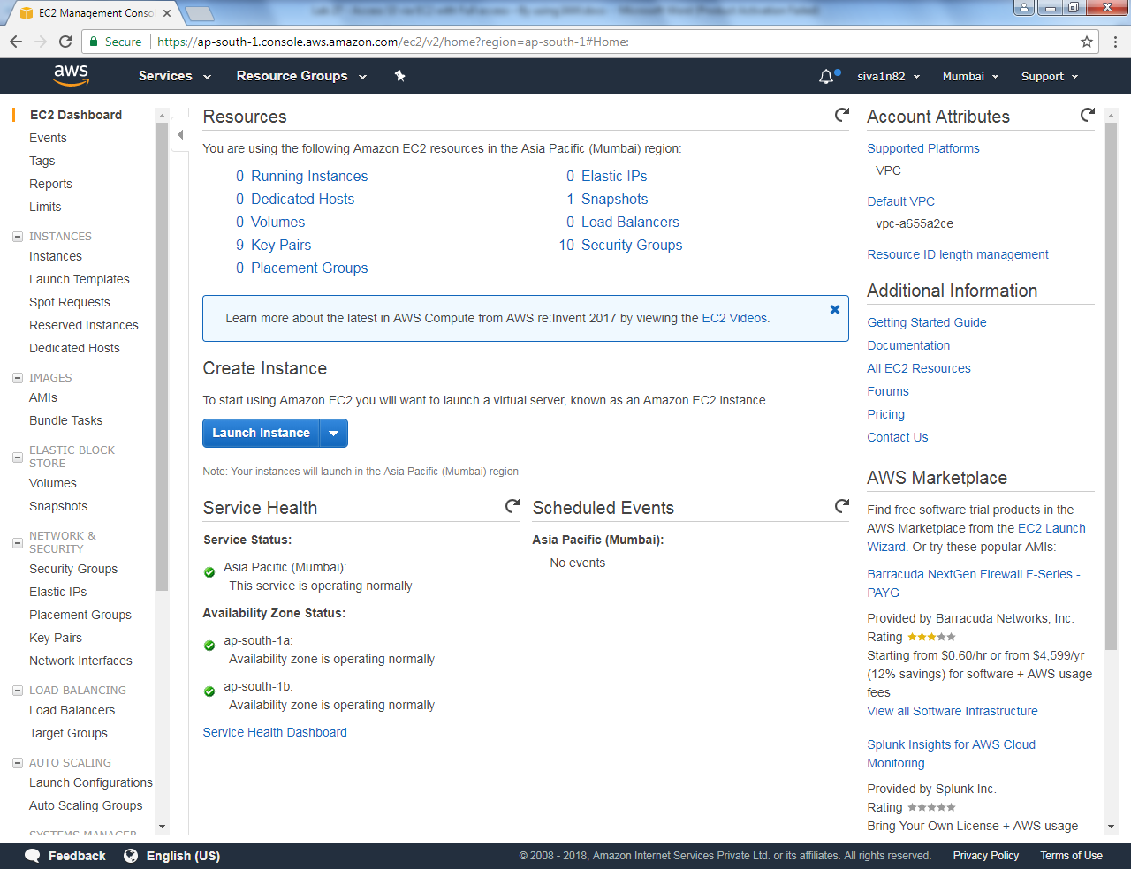

Select “Amazon Linux”.

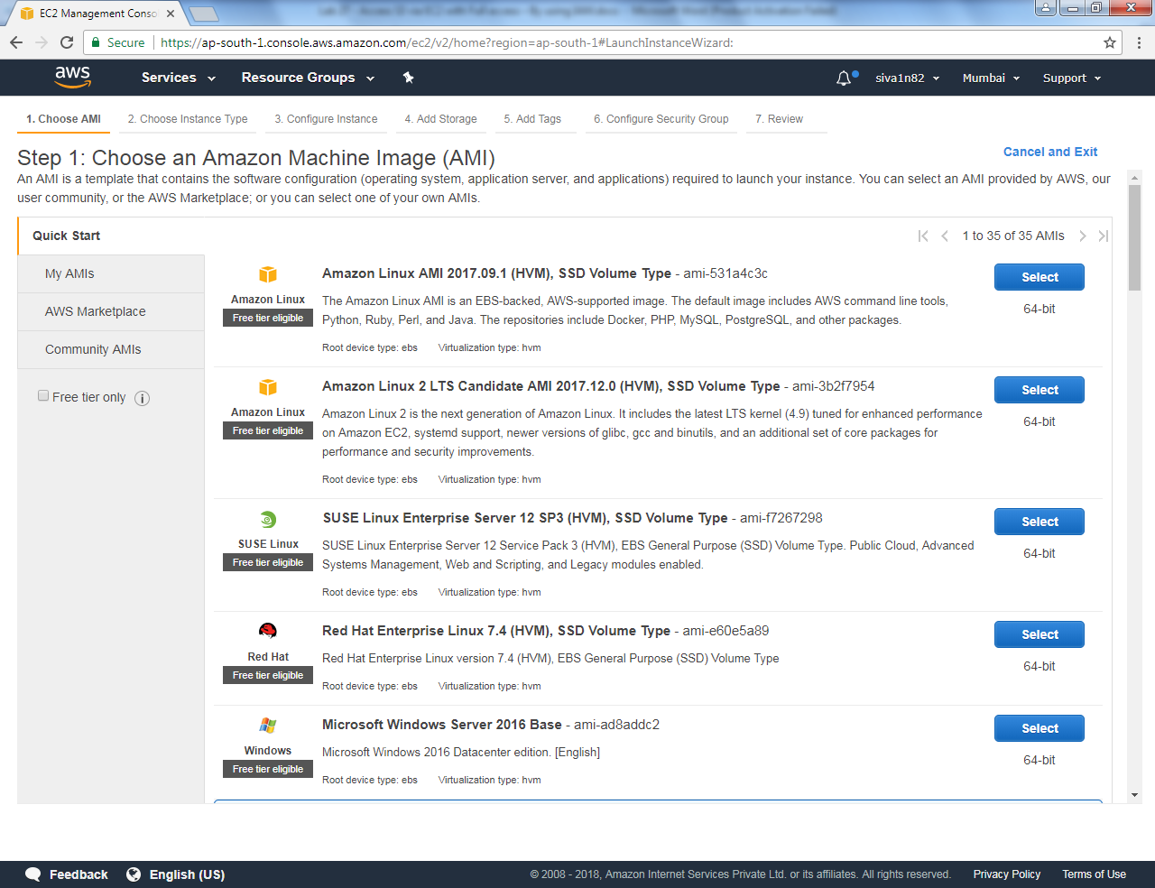

Select “t2.micro”.

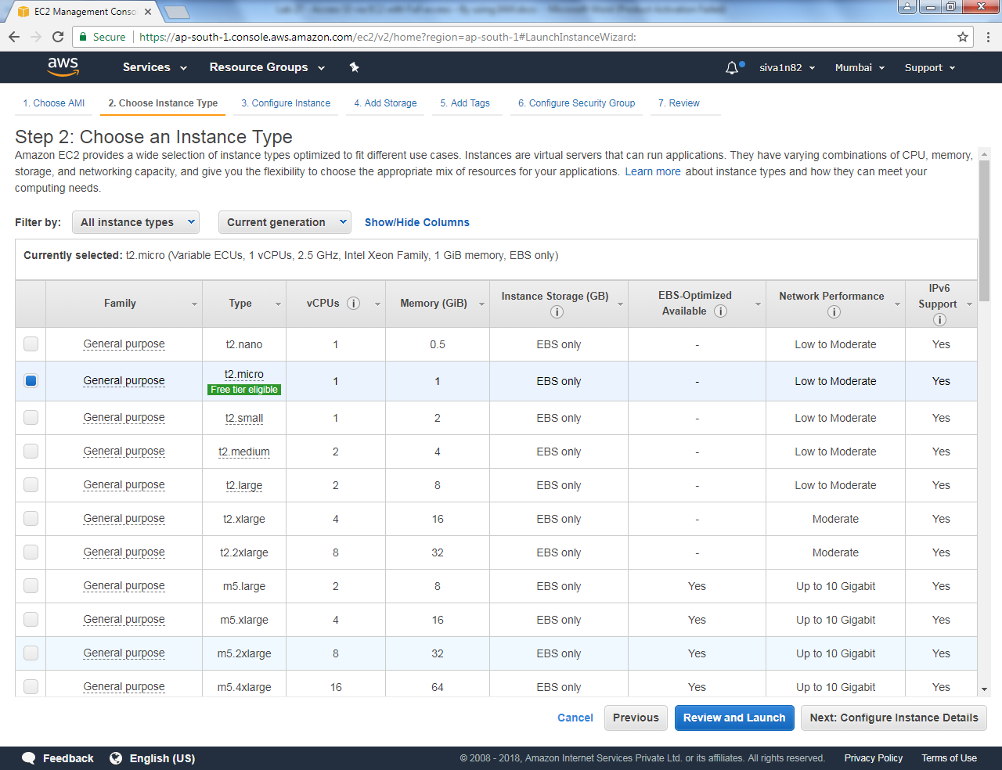

Click “Next”.

Select VPC and Subnet, then select IAM role as “S3AccesswithEC2”.

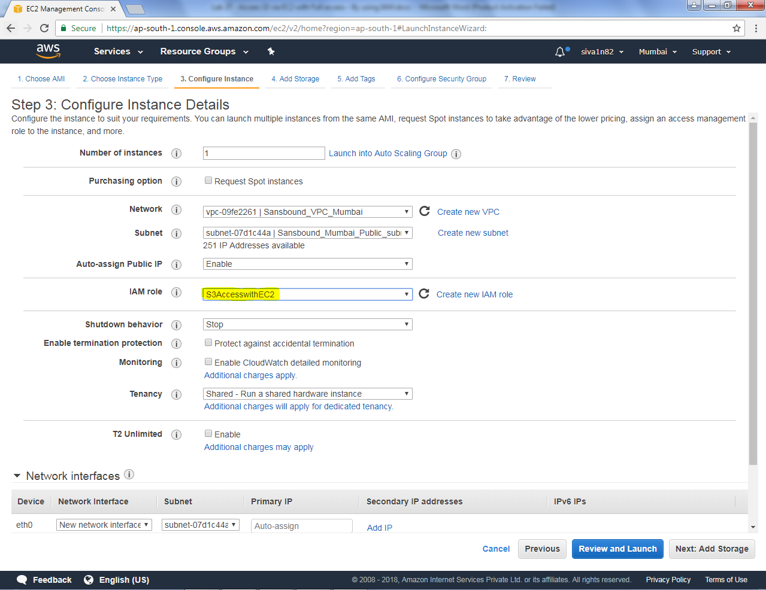

Click “Next”.

Click “Next”.

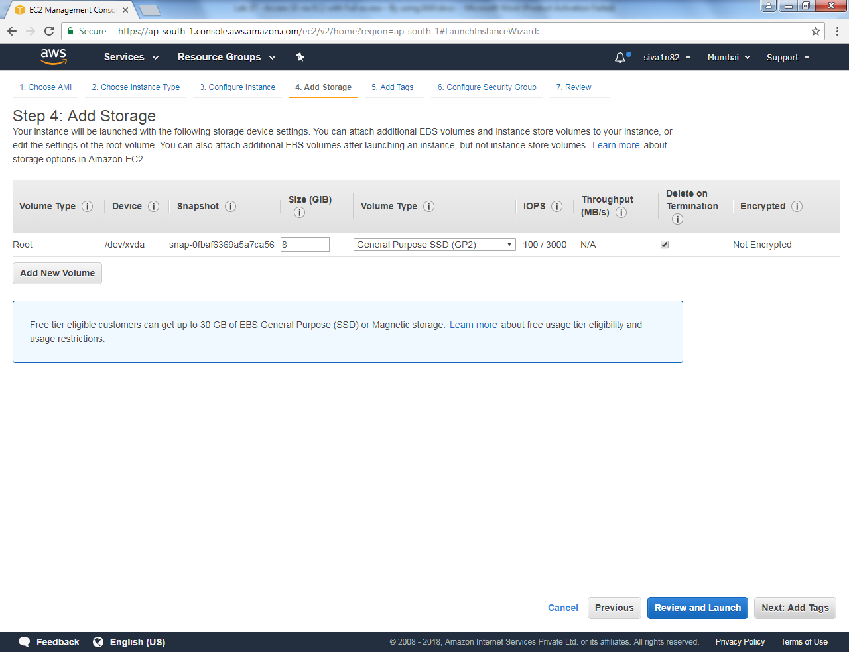

Type Name as Linux Instance.

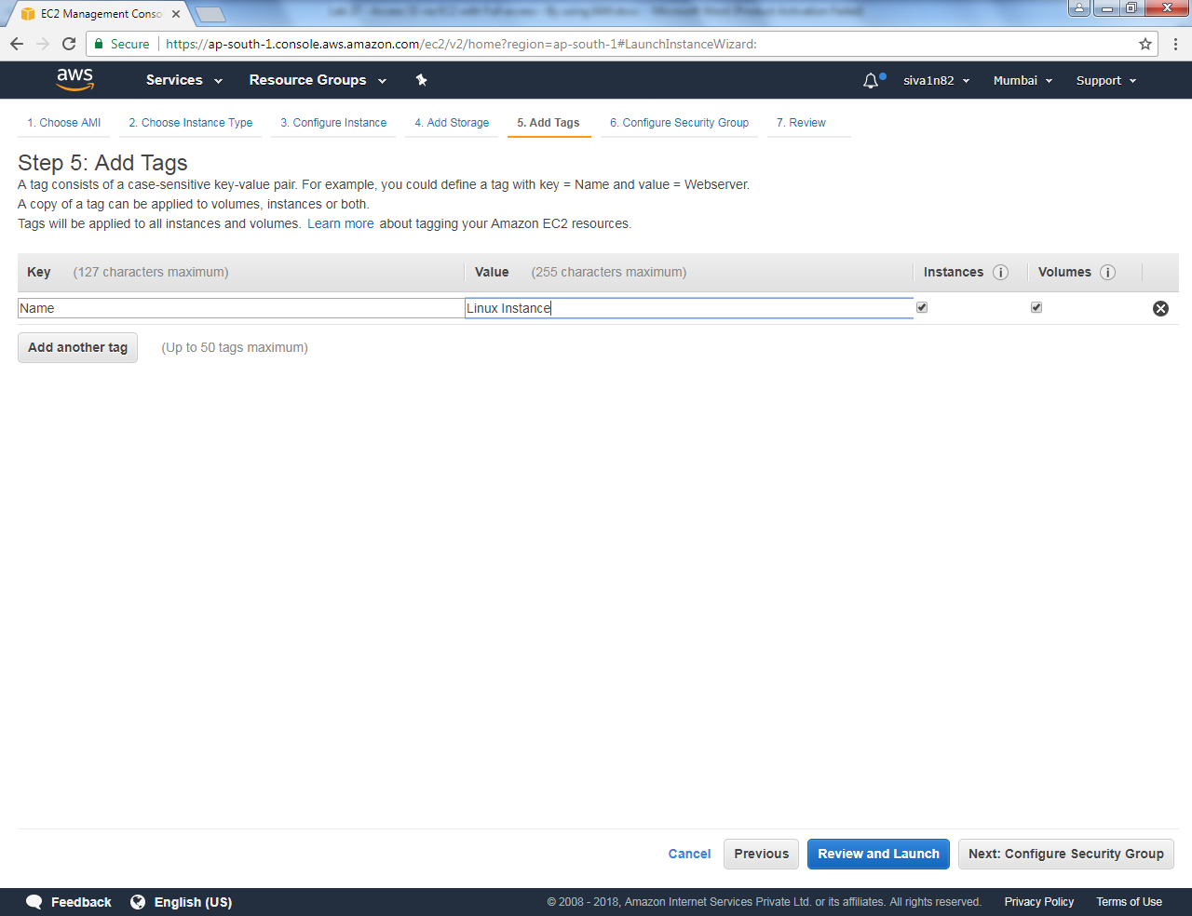

Click “Next”.

Create a new security group for access ssh port.

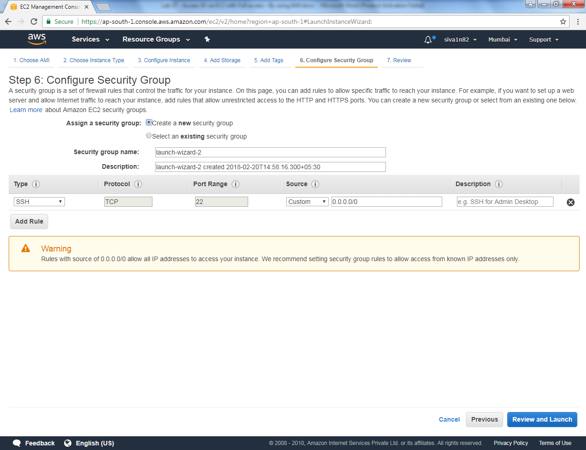

Click “Launch”.

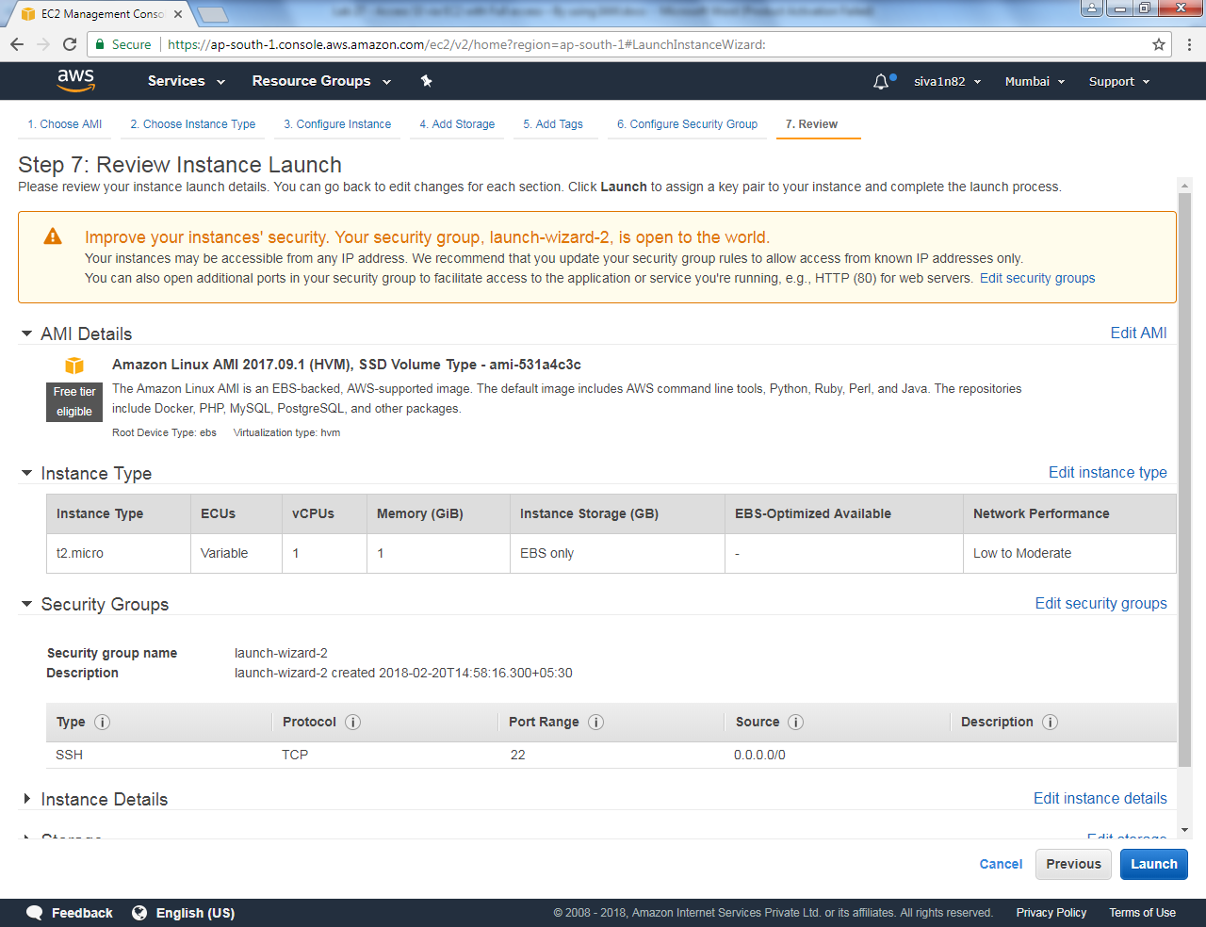

Choose the key and Click Launch instances.

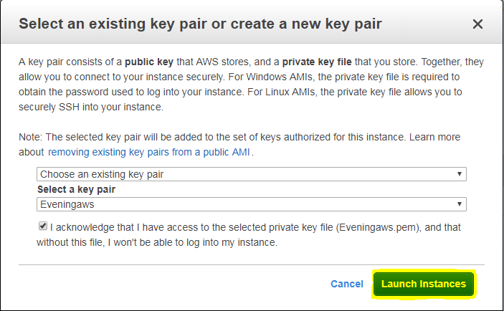

Click “View instances”.

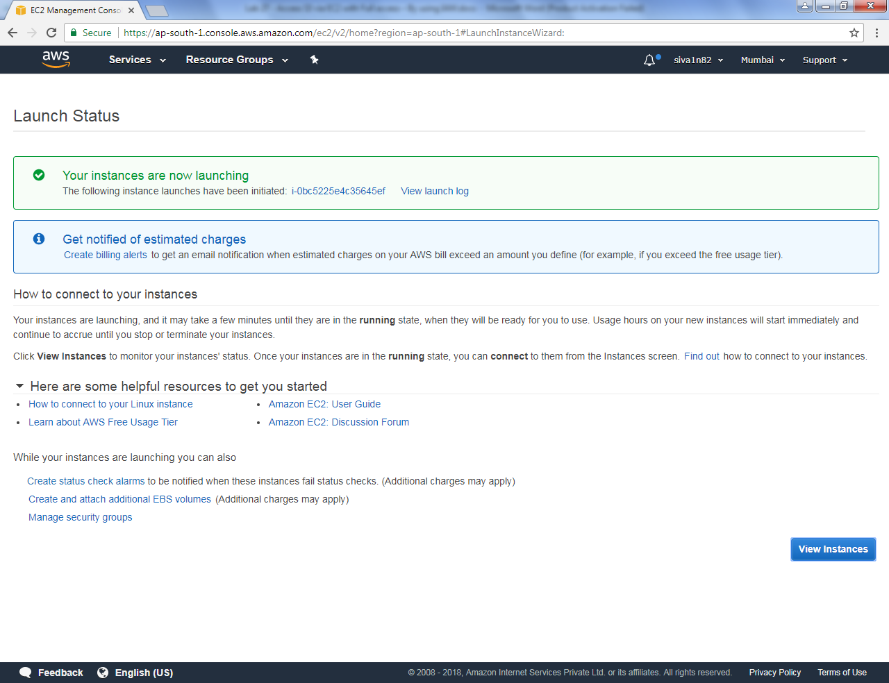

Login to Linux instance by using SSH.

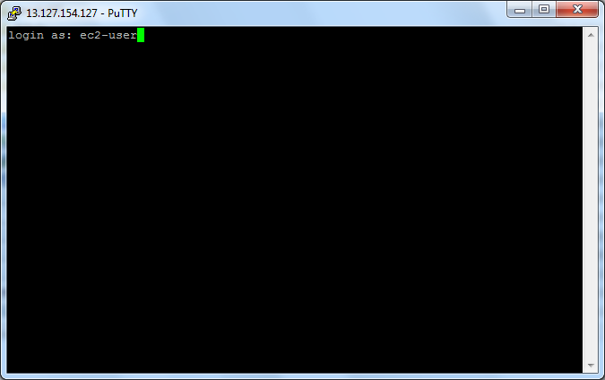

Type sudo -i

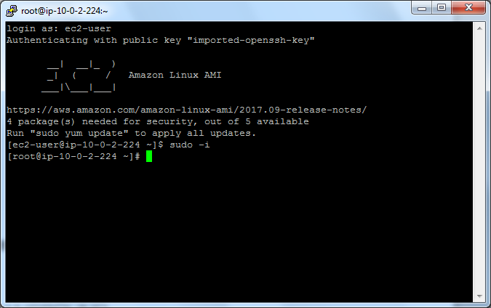

Login to aws configure mode by using access key ID and secret access key. You must type the region to configure.

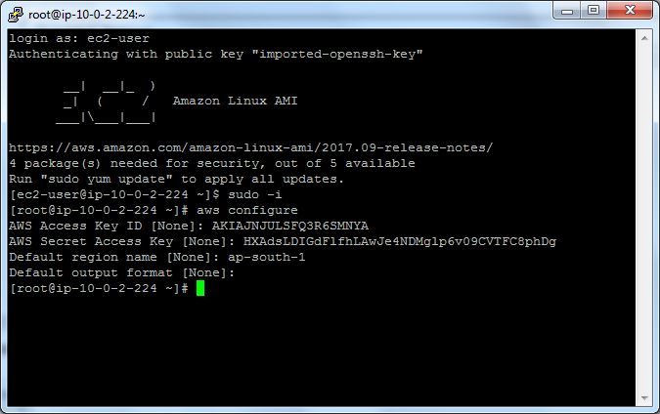

Type aws s3 ls command to list the bucket.

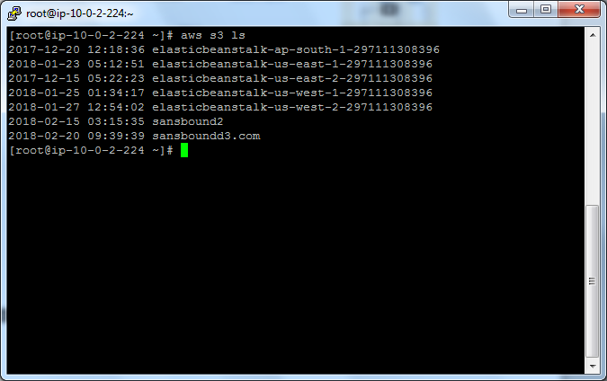

Type aws s3 rb s3://sansboundd3.com

Successfully removed the bucket.

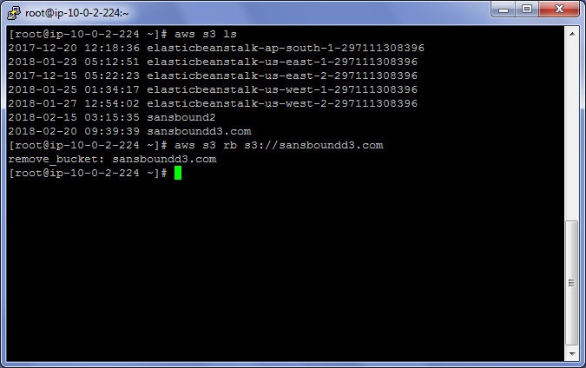

Type

Aws s3 mb s3://aws.sansbound.com

Succesfully created the bucket.

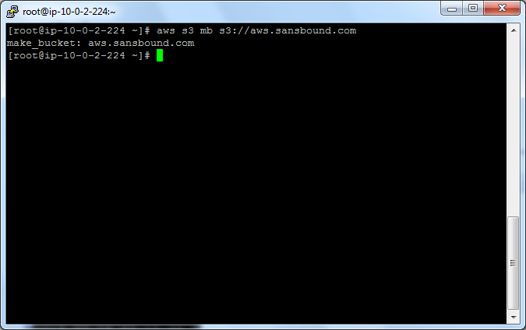

Tyep

Aws s3 ls

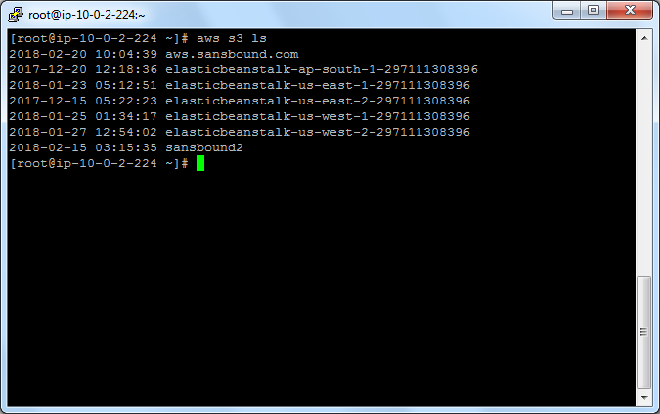

Bucket details listed successfully.